19L-1316

EE-2A:

HAFIZ AHMAD

LAB REPORT 11:

**OBJECTIVE:**

Things that will be covered in today’s lab:

To be able to understand the working of files and functions.

**Codes:**

**Exercise 1: (10 points)**

**Modify the code B in Exercise - 1 such that it reads all integers from an input file and writes the number, square of that number and cube of that number separated by tab to an output file. Sample input and output files are given below. Use pow function of cmath library.**

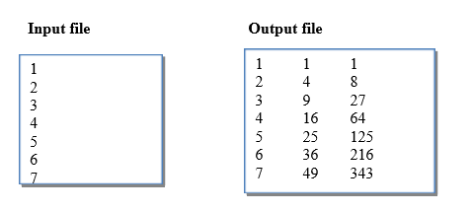

#include <iostream>

#include <fstream>

#include <cmath>

using namespace std;

void main()

{

ifstream cin;

ofstream cout;

cin.open("inputfile.txt");

cin.open("outputfile.txt");

int x;

while(!cin.eof())

{

cin>>x;

cout<<x<<" "<<pow(x,2)<<" "<<pow(x,3)<<endl;

}

cin.close();

cout.close();

}

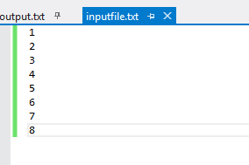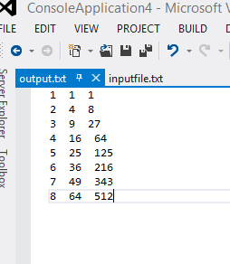

Exercise 2: (10 points)

File “quiz_result.txt” stores the result of three quizzes for 20 students. The format of the file is shown below. The first column in the file lists the marks of first quiz, second columns lists the marks of second quiz and third column is for third quiz. Write a program, which reads the marks of all the quizzes for each student, and calculate and display the total marks obtained by each student.

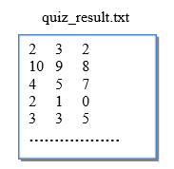

#include <iostream>

#include <fstream>

#include <cmath>

using namespace std;

int main()

{

ifstream cin;

ofstream cout;

cin.open("quizresult.txt");

cout.open("output.txt");

int x[3],sum=0;

while(!cin.eof())

{

for(int i=1;i<=3;i++)

{

cin>>x[i];

sum=sum+x[i];

cout<<x[i];

}

cout<<sum<<endl;

}

cin.close();

cout.close();

}

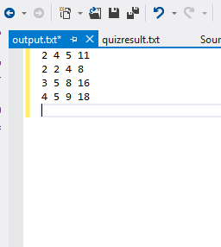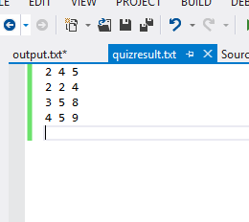

**Post Lab**

The file named fact_data.txt contains integers in each line. Write a program that reads each integer and then finds and displays the factorial of that integer as well as write it in a file named fact_out.txt in a new line. Factorial should be found using a function named factorial.

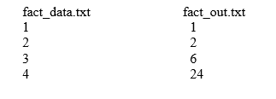

#include <iostream>

#include <fstream>

#include <cmath>

using namespace std;

void main()

{

ifstream cin;

ofstream cout;

cin.open("fact_data.txt");

cin.open("fact_out.txt");

int x;

while(!cin.eof())

{

cin>>x;

int factorial=1;

for(int i=1;i<=x;i++)

{

factorial=factorial*i;

}

cout<<x<<" "<<factorial<<endl;

}

cin.close();

cout.close();

}

